National Endoscopy Database (NED)
Website Specification

Version: 1.00
Date: 11/12/2013

Contents

1 Contents 2
2 Introduction 3
2.1 Background 3
2.2 Purpose of this document 3
2.3 Scope 3
2.4 Assumptions 4
2.5 References 4
2.6 Abbreviations & Terminology 5
3 Upload Interface 6
4 Queue Update Service Interface 7
5 Security 8
6 Batch processing 8

Introduction
This document provides information concerning how to use the National Endoscopy Database website JETS to upload procedure data without using the web service interface.

Background
The JAG is introducing a facility to enable Endoscopy System Suppliers to submit, electronically, procedure information on behalf of endoscopists to a national database, NED.
Endoscopy System Suppliers who wish to use the NED Import service must register with the JAG to do so.
Use of the NED Import service will remove the need for endoscopists to manually key in procedure data thus saving time, improve quality and increase coverage of procedures recorded throughout England.

Purpose of this document
This document provides guidance on using the JETS website to enable an endoscopy supplier to test their own generated procedure data files in a purpose built test environment.
It is aimed, primarily, at technicians and testers who need a detailed understanding of how to submit procedure data to NED.

Scope
This document is one of a number that when taken together describes the NED Import service. The complete documentation set is shown in the following table, with this document highlighted.
Document | Description
Business Message Specification  SendBatchMessage  Version 1.01 | Defines the content of the business message that will pass from the Local Endoscopy System to NED.
Business Message Specification  GetBatchStatusMessage  Version 1.01 | Defines the content of the message received by the Local Endoscopy System when querying the status of a procedure batch in NED.
Interface Specification  Version 1.00 | Defines the operational interface and security requirements for connecting to NED Import service including the transmission of data.
Website specification  Version 1.00 | Defines how to use the NED website to upload data manually and monitor procedure data being imported.

The focus of this document is the Website specification.

Assumptions
The content of this document is based on the following assumptions.
- The Reader is familiar with the Business Message specification document.
- Have an understanding of Web Service technology.

References
The table below lists references to other relevant documentation. References to these documents, within the text of this document, are made using the square-bracket notation shown in the “Ref” column of the table.
Ref | Description
[1] | Business message specification document.
[2] | Website specification document.

Abbreviations & Terminology
This section provides definitions of abbreviations and unusual terminology used in this document.
Abbreviations
Abbreviation | Meaning
ES | Endoscopy System Supplier
NED | National Endoscopy Database
JETS | JAG Endoscopy Training System (www.jets.nhs.uk)
JAG | Joint Advisory Group on GI Endoscopy (www.thejag.nhs.uk)
ODS | Organisation Data Service (ODS) codes  For example: RGQ for IPSWICH HOSPITAL NHS TRUST.  A complete listing can be found in the blow  (http://www.connectingforhealth.nhs.uk/systemsandservices/data/ods/datafiles/tr.csv/view)
ERS | Endoscopy Reporting System

Terminology
Term | Meaning

The JETS Website

Access
A Test version of the JETS website has been setup and made available on the internet to allow Endoscopy System Suppliers to test their own generated files work in a test environment.
To access the Test JETS website, User your internet browser to navigate to the following web address:
http://ned.weblogik.co.uk
Logging in
To login to the website click the Login/Register button in the top right hand corner of the home page to reveal the sign in panel.
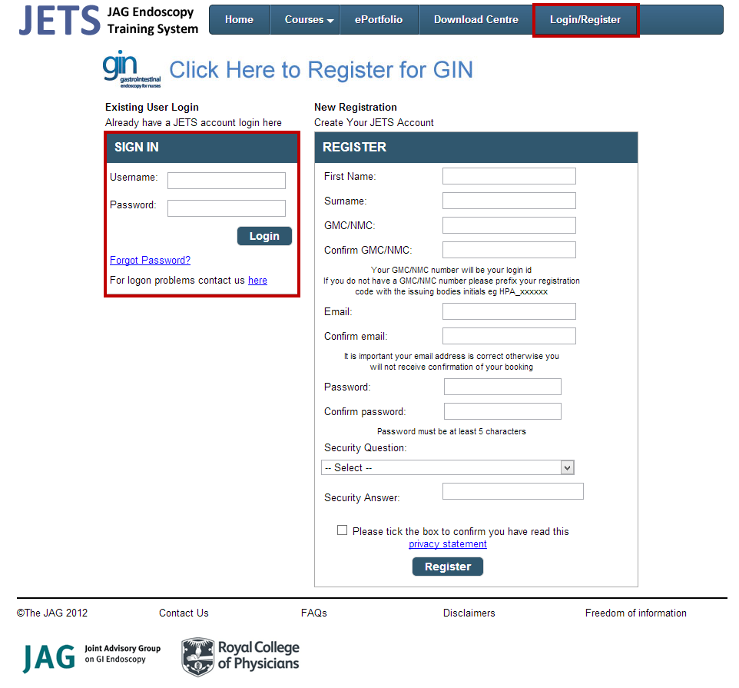

Each supplier will be provided with the following accounts which will be allocated to a site. This will allow each supplier to login, Upload date and check the data has been correctly allocated to the appropriate endoscopist.
Account Type | Description
Manager | This account can be used to upload files manually to the JETS website
Trainee | The Trainee account can be used to upload procedure data against their unique ID/professional body.
Trainer | Trainer accounts will contain a duplicate of the trainee’s information given they are responsible for the procedure.

When provided with these accounts and a test site it is important to create test files the corresponding unique IDs/professional body to ensure the file is accepted by JETS.

Uploading procedure data files

To upload data into the JETs website login as a Manager and click the ePortfolio dropdown menu item and select NED Upload.
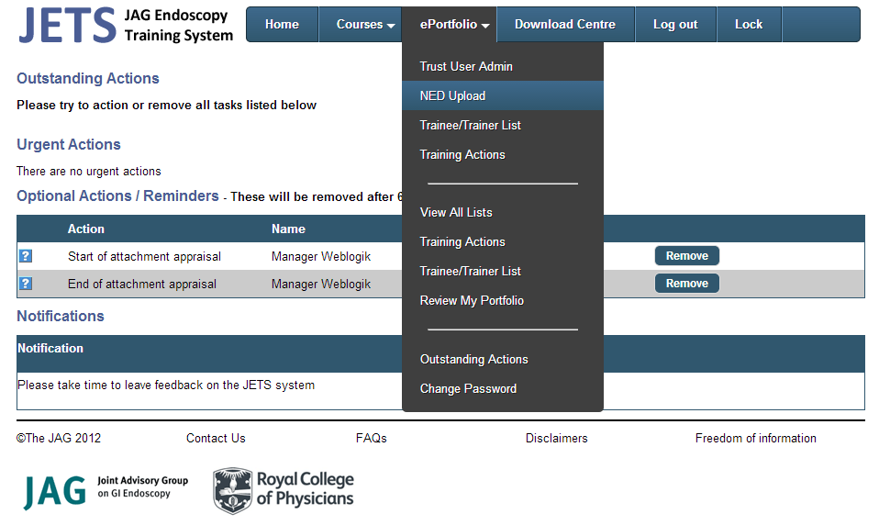
The NED Upload screen will be displayed as per below.
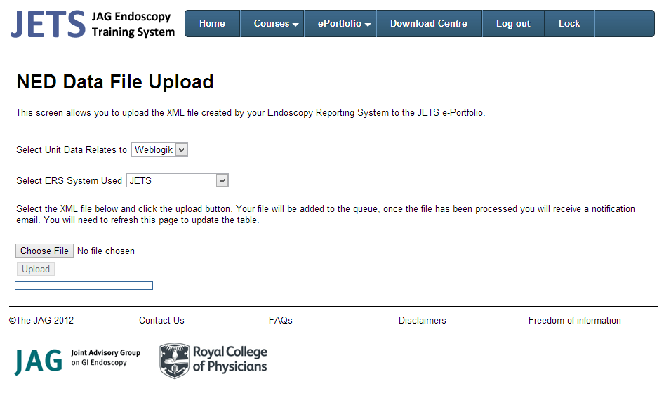

The Unit will be pre-set to a test unit assigned to your around.
The ERS System list allows the manager to identify the source system where the file has come from.
Select Choose File to select an xml file in the format of the SendBatchMessage specification that has been generated by the ERS system.
Clicking upload will start the file upload process.

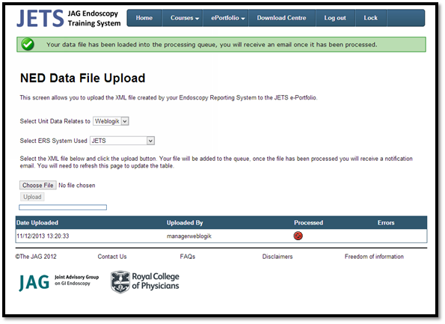
Once queued for processing the file will appear in the table under the upload form.
Unit Managers can visit the upload screen at any time to see the status of their uploaded files.
Understanding the status icons
Icon | Meaning
 | File Queued for processing
 | File Processed
 | A file validation has occurred ( Hover over the icon to see the validation error )

Typically the processing will happen within 5 minutes.

Testing

Trainee Access
Login to the JETS website using the Trainee Credentials provided.
Once logged in you can navigate to your uploaded session lists containing procedures information.
To do this select the ePortfolio dropdown menu and select All lists.
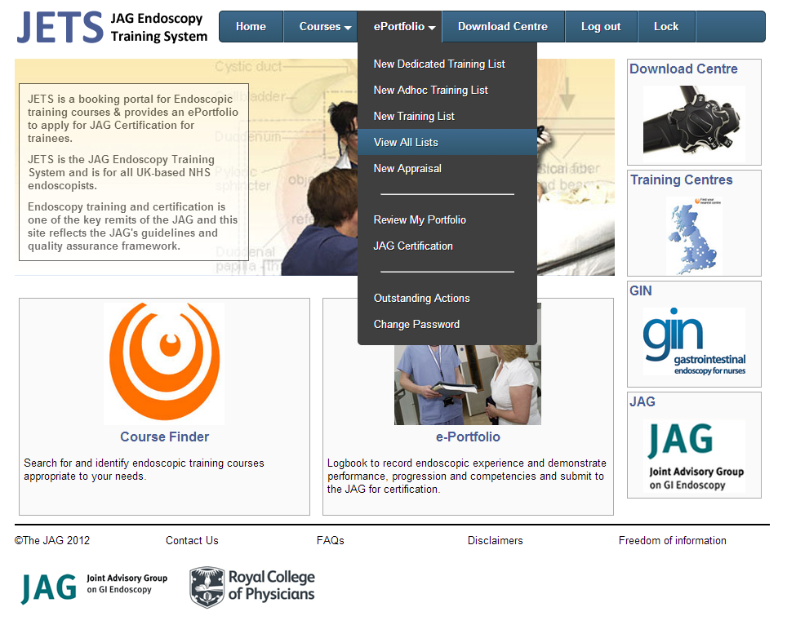

When the page loads the Trainee will be prevented with their uploaded session lists. In this example one file containing on session has been uploaded.
A padlock icon will appear against the session to indicate that the session list is locked from editing online. This is because it is an uploaded list.
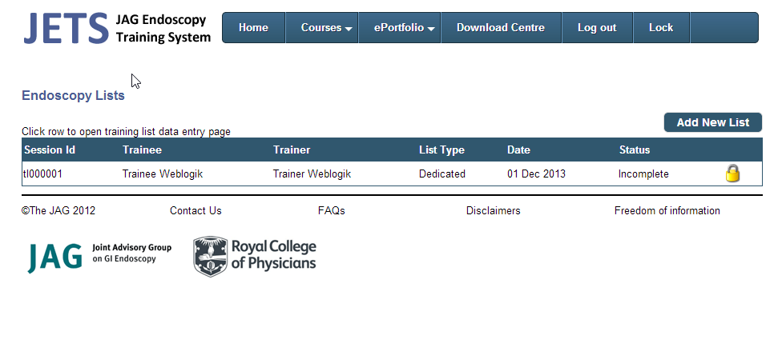
Clicking on the session list will navigate the trainee to the Training List Summary page. In this example you can see that the session list contains one OGD procedure.
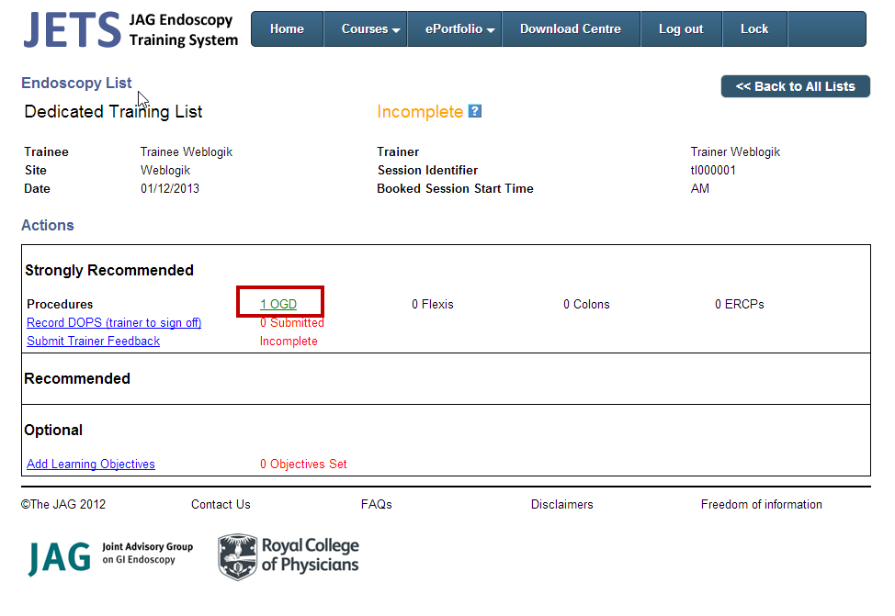
Clicking on the number of procedures highlighted above will navigate the trainee to list of procedures as shown below which shows the OGD procedure referred to earlier.
As per the session list a padlock icon will appear against the procedure to indicate that it is locked from editing online because it is an uploaded procedure.

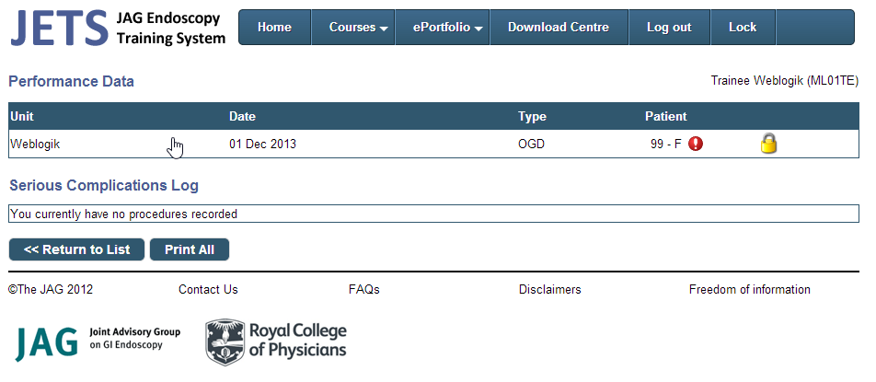
Clicking on the procedure will navigate the trainee to procedure details page as shown on the next page. You will notice that all the fields are disabled for editing due to the procedure being locked.

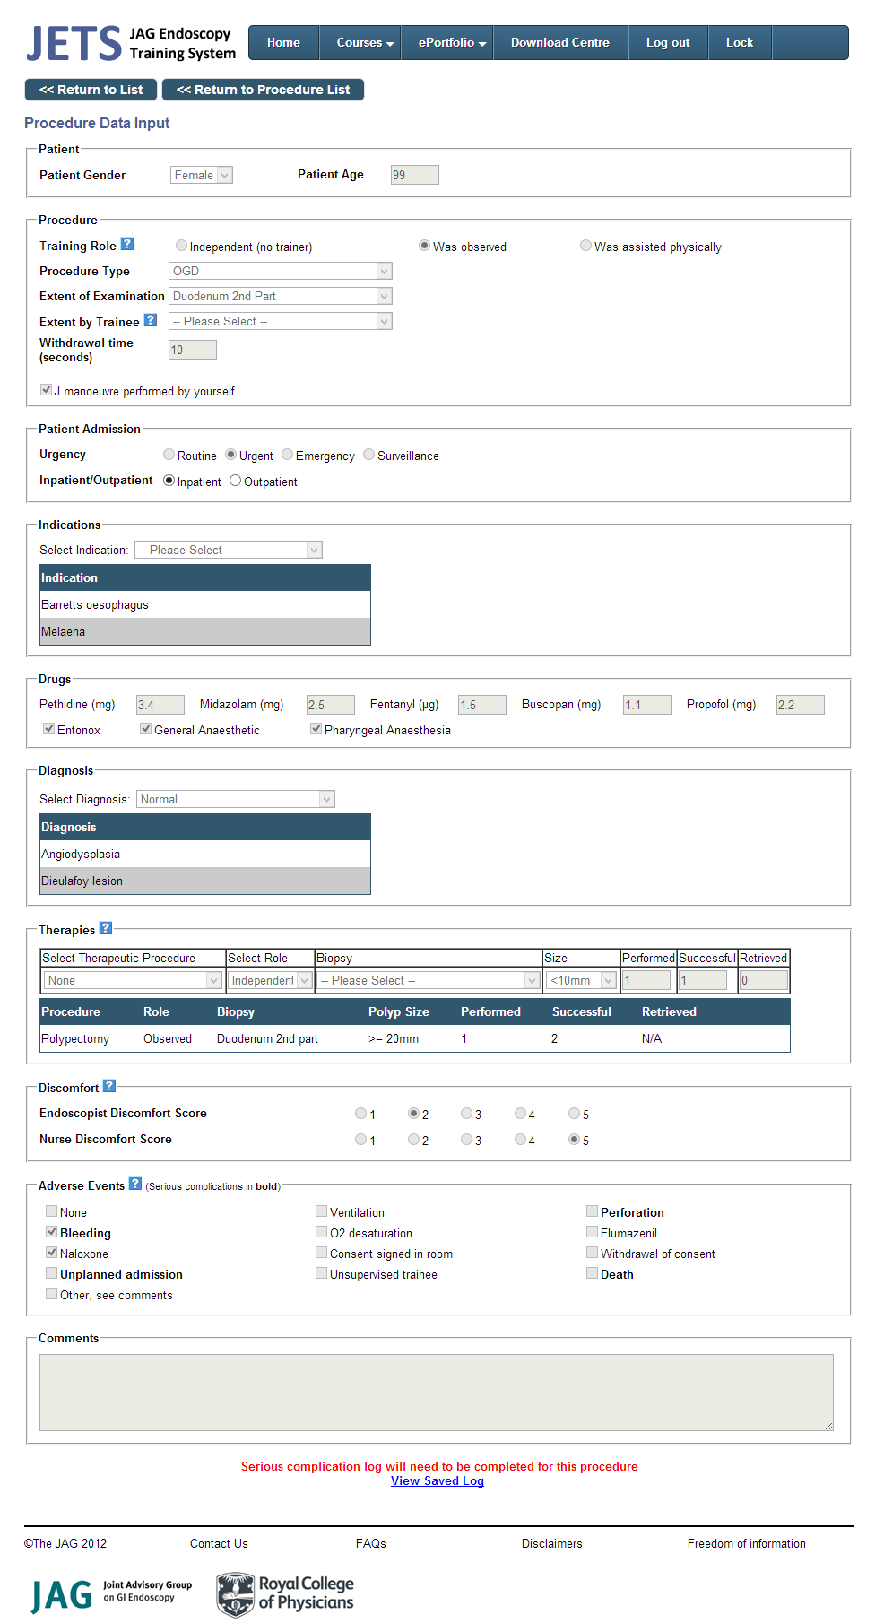

Trainer Access
When a trainee’s procedure is uploaded a copy is also given to the responsible trainer.
Therefore a trainer can login and view their procedures in the same way that a trainee views their procedures detailed in the previous section.

